Plant Care AI

AI-Powered Plant Disease Detection System

Project Report

1. Introduction
Food security and the world economy depend heavily on agriculture. Early detection of plant diseases is one of the largest problems farmers face. Diseases can spread quickly and result in large crop losses if they are not detected early.
Expert manual inspection is the foundation of traditional plant disease detection techniques. However, farmers in remote areas may not always have access to this process, which is costly and time-consuming.
Automated systems can now evaluate plant photos and accurately identify diseases thanks to the development of deep learning and artificial intelligence.
An AI-powered web application called Plant Care AI enables users to upload photos of plant leaves and quickly determine whether the plant is disease-free or not.
To provide real-time disease detection, the system makes use of a Flask web framework and a deep learning model built on the MobileNetV2 architecture.

2. Problem Statement
Globally, plant diseases result in significant agricultural losses. Farmers frequently find it difficult to promptly and accurately diagnose illnesses.
Among the issues at hand are the following:
• Inability to obtain agricultural specialists • Delay in the diagnosis of a disease • Disease transmission prior to detection • Economic loss and crop damage
As a result, an automated system that uses image recognition to swiftly and precisely identify plant diseases is required.

3. Objectives
The main objectives of this project are:
- to develop an AI-powered system that recognizes plant diseases from leaf photos.
- to create a simple web interface that enables users to upload plant photos.
- to classify plants as either healthy or sick using a deep learning model.
- to provide farmers and researchers with accurate and timely results.
- to demonstrate the practical application of deep learning in agriculture.

4. Project Scope
The scope of this project includes:
• Image-based plant disease detection; web-based user interface; classification using deep learning; and real-time prediction using trained models
Future versions of the system could include:
• Disease treatment recommendations; cloud deployment; mobile application support; and increased accuracy with larger datasets

5. Literature Review
Numerous studies have looked into the use of machine learning and deep learning techniques for plant disease detection.
Traditional image processing methods relied on the manual extraction of features like shape, colour, and texture. Nevertheless, these methods' accuracy and scalability were constrained.
Automated feature extraction is now possible thanks to Convolutional Neural Networks (CNNs). VGGNet, ResNet, and MobileNet are CNN models that excel in image classification tasks.
The MobileNetV2 architecture is particularly well suited for this application because it is efficient, lightweight, and works well even on devices with low processing power.
Recent research has shown that deep learning models trained on plant disease datasets can achieve accuracy above 90%.

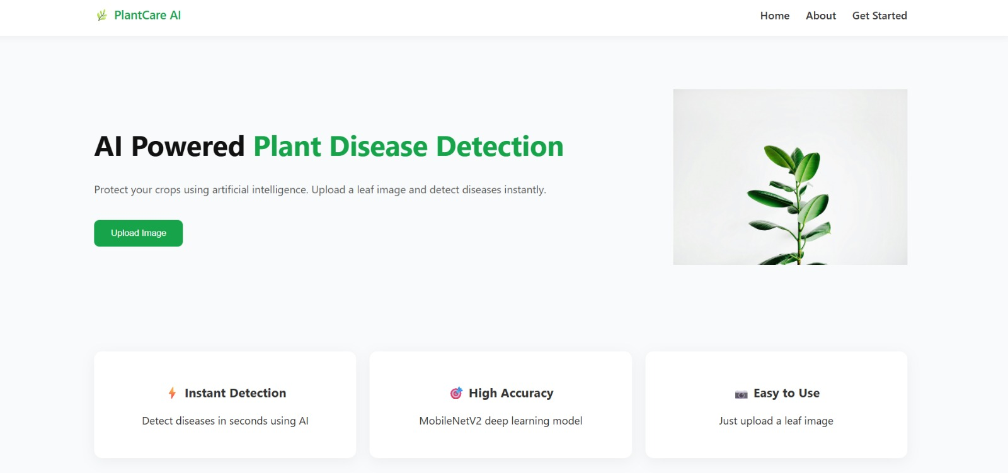

6. Techniques
The steps the system takes are as follows:
- Upload an Image The user uses the web interface to upload an image of a plant leaf.
- Preprocessing of Images The uploaded image is normalized and resized to fit the deep learning model's input format.
- Prediction of the Model The trained MobileNetV2 model receives the pre processed image.
- Classification of Diseases The class label that corresponds to the type of plant and disease is predicted by the model.
- Display of the Results The predicted plant type and whether it is healthy or sick are shown by the application.
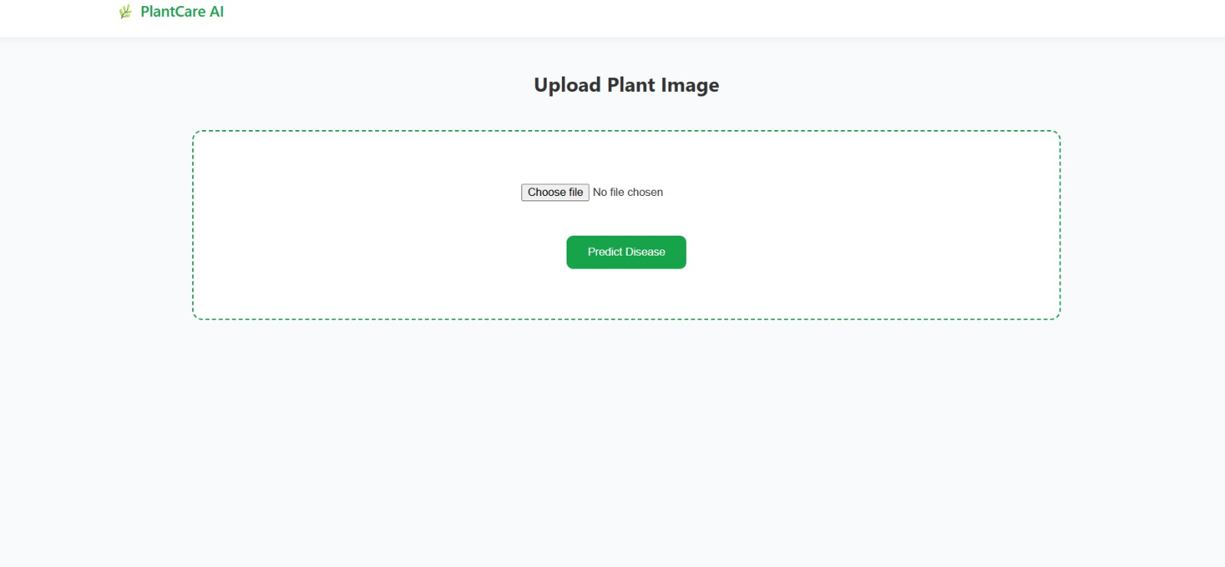

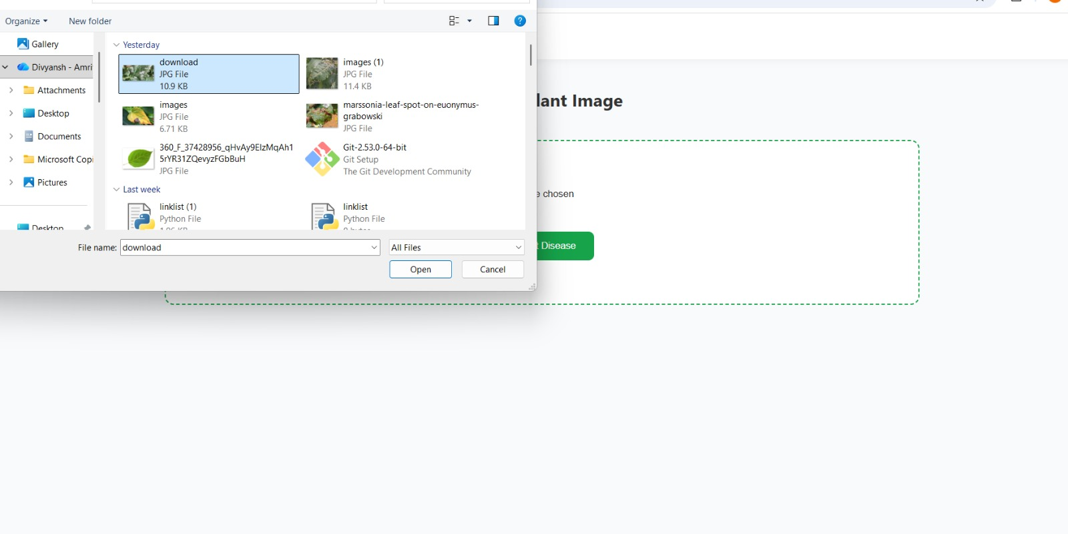

7. Architecture of the System
There are three primary parts to the system architecture:

First. Front-end
The frontend is constructed with:
• Hex • The CSS
It offers an interface for users to upload photos of plants and see the outcomes.

Two. Backside
The backend is created with:
• Python. • Framework for Flask
It manages prediction, model loading, and image processing.

Third. Model of Deep Learning
Using image data, the trained MobileNetV2 model completes the classification task.

8. Technologies Used

Language for Programming Language for Programming
Python.

Framework for Websites
A flask

Framework for Deep Learning
Keras and TensorFlow

Front-end technologies Front-end technologies
Hex The CSS

Bookstores
NumPy
Pillow
TensorFlow
The NumPy

9. Utilized Dataset
The following dataset was utilized to train the model:
The Augmented New Plant Diseases Dataset
Thousands of photos of both healthy and sick plant leaves can be found in this dataset.
The dataset consists of:
• Apple
• Tomato
• Potato
• Corn
• Grape
It contains 38 different disease classes, including healthy plants.

10. Model Employed
MobileNetV2, a lightweight convolutional neural network intended for effective image classification, is used in the project.
Benefits of MobileNetV2
• High precision
• Architecture that is lightweight
• Quicker inference and training
• Ideal for applications that require real-time
The model's performance was enhanced through transfer learning.

11. Implementation
The system was implemented using the following methods:
- Take pictures of plant leaves and prepare the.
- A MobileNetV2 model is trained using TensorFlow.

- It is necessary to save the trained model.

- Make a Flask backend in order to load the model.

- Create the HTML pages for the user interface.

- Connect the front end and back end.

- Display the prediction results from 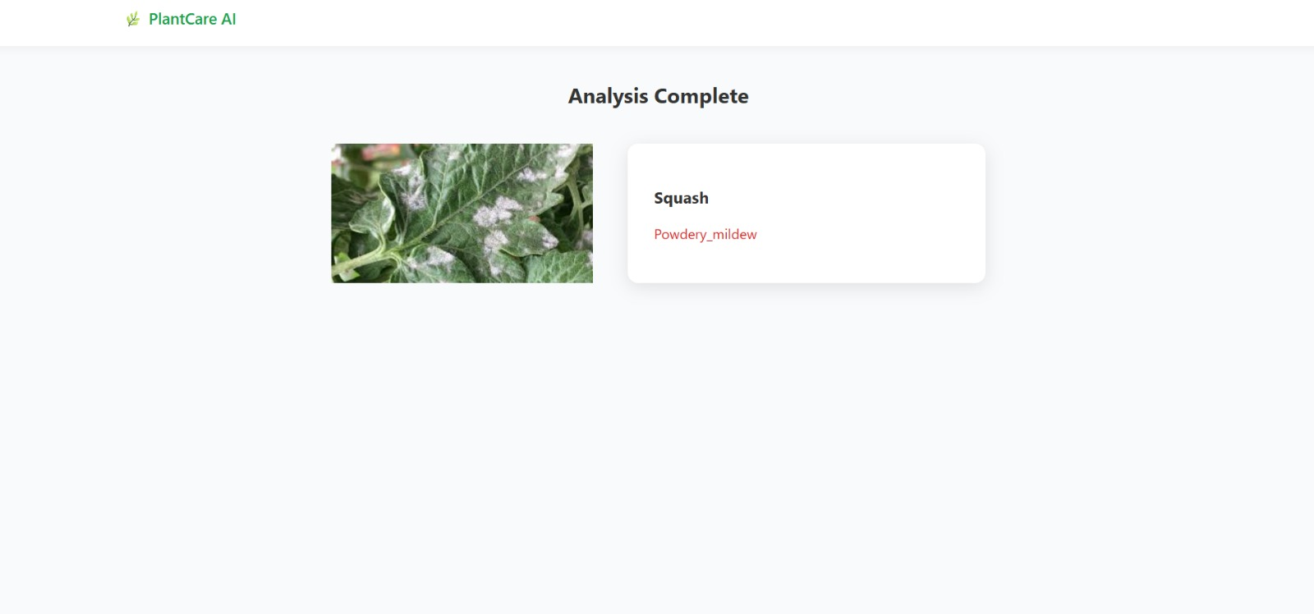the webpages

12. Outcomes
From uploaded photos, the system successfully identifies plant diseases.
Features attained:
• Quick forecasting
• Precise categorization
• Easy-to-use interface
• Real-time analysis of images
The majority of the dataset's plant disease classes show good performance from the model.

13. Advantages
• Rapid illness identification
• User-friendly interface
• lessens reliance on specialists
• can assist farmers in acting quickly
• demonstrates how AI can be used practically in agriculture

14. Restrictions
• Image quality affects accuracy.
• restricted to illnesses found in the dataset
• requires computer power and the internet.

15. Upcoming Enhancement
It is possible to enhance the system by: It is possible to enhance the system by:
• Including suggestions for illness treatment Including suggestions for illness treatment
• expanding the size of the dataset expanding the size of the dataset
• Putting the application online Putting the application online
• Creating a mobile application Creating a mobile application
• Using sophisticated architectures to increase model accuracy Using sophisticated architectures to increase model accuracy

16. Conclusion
The potential of artificial intelligence in agriculture is demonstrated by Plant Care AI. The system can automatically identify plant diseases from leaf photos by fusing web technologies with deep learning.
The system is appropriate for real-time applications because MobileNetV2 enables effective and precise image classification.
These AI-based tools can lower crop losses, increase agricultural productivity, and assist farmers in early plant disease detection.

17. References
- TensorFlow Documentation
- Keras Deep Learning Library
- Plant Village Dataset Research Papers
- MobileNetV2 Architecture Paper
- Flask Web Framework Documentation

